**Download Jenkins**

The official website for Jenkins is [Jenkins](https://jenkins-ci.org/). If you click the given link, you can get the home page of the Jenkins official website as shown below.

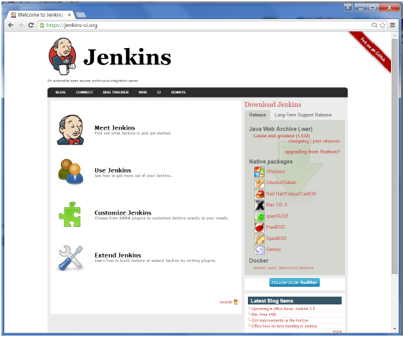

By default, the latest release and the Long-Term support release will be available for download. The past releases are also available for download. Click the Long-Term Support Release tab in the download section.

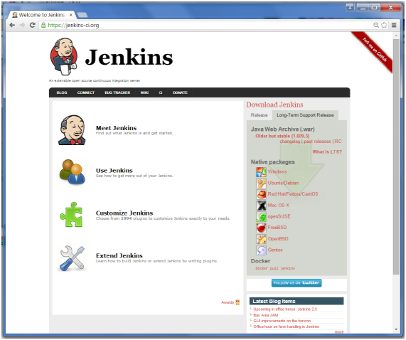

Click the link “Older but stable version” to download the Jenkins war file.

**Starting Jenkins**

Open the command prompt. From the command prompt, browse to the directory where the jenkins.war file is present. Run the following command

D:\>Java –jar Jenkins.war

After the command is run, various tasks will run, one of which is the extraction of the war file which is done by an embedded webserver called winstone.

D:\>Java –jar Jenkins.war

Running from: D:\jenkins.war

Webroot: $user.home/ .jenkins

Sep 29, 2015 4:10:46 PM winstone.Logger logInternal

INFO: Beginning extraction from war file

Once the processing is complete without major errors, the following line will come in the output of the command prompt.

INFO: Jenkins is fully up and running

**Accessing Jenkins**

Once Jenkins is up and running, one can access Jenkins from the link − **http://localhost:8080**

This link will bring up the Jenkins dashboard.

